# Department of Computing

## **Name: Mahum Samar**

## **CMS ID: 290647**

## **Class: BSCS-9B**

# CS220: Database Systems

# Lab 00: MySQL and Workbench Environment

# Time: 2:30 pm -5:00 pm

# Instructor: Dr Shams Qazi

# INSTALLATION OF MySQL SERVER AND WORKBENCH

Screen after installing the workbench.

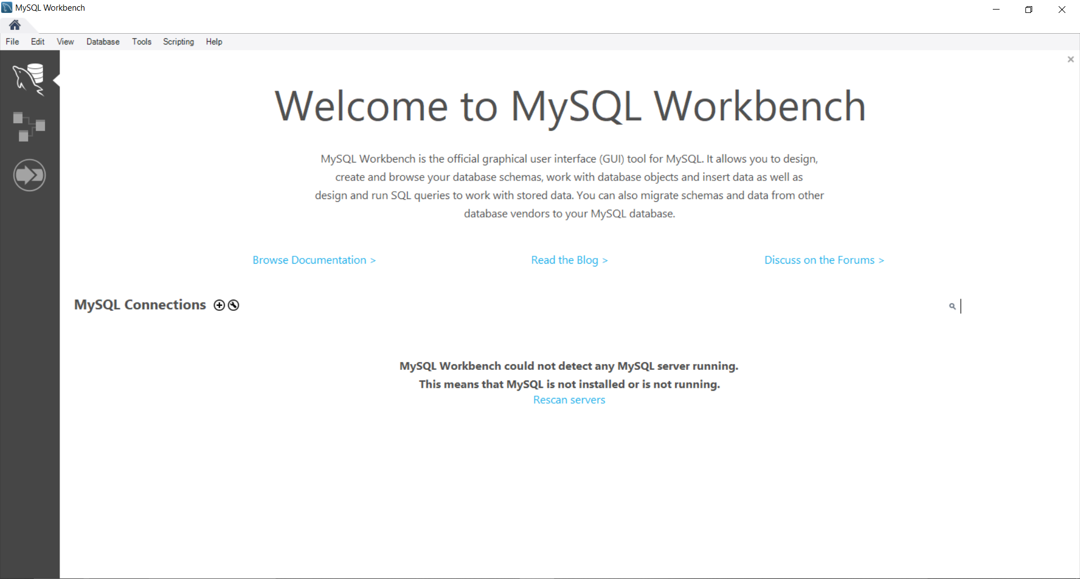

Establishing the connection with the server.

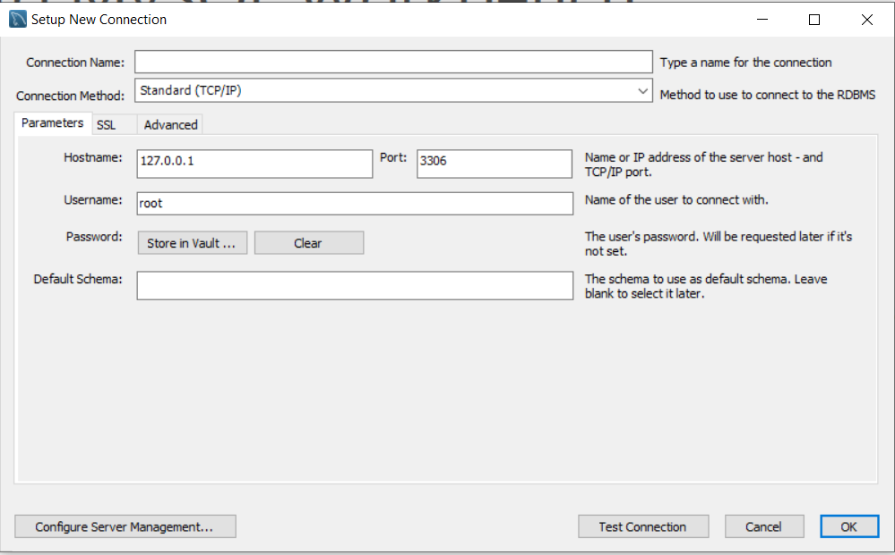

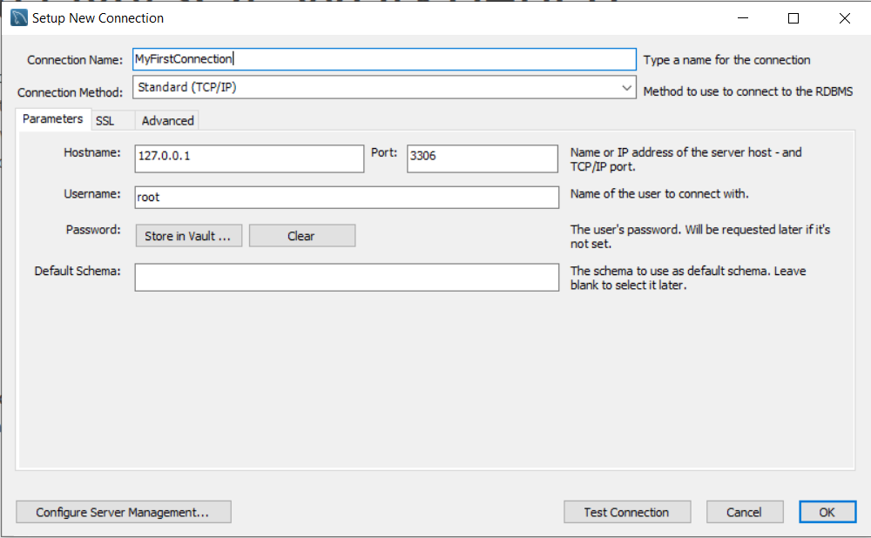

Workbench after successful creation of connection.

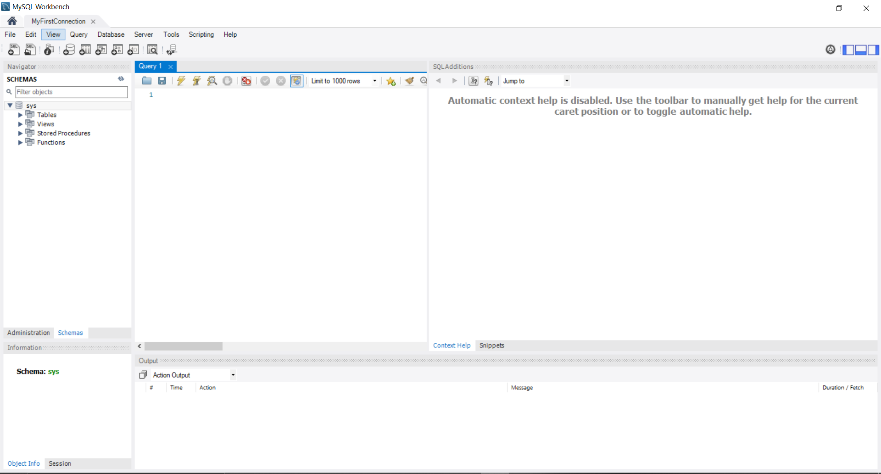

Opening the sakila-schema.sql file.

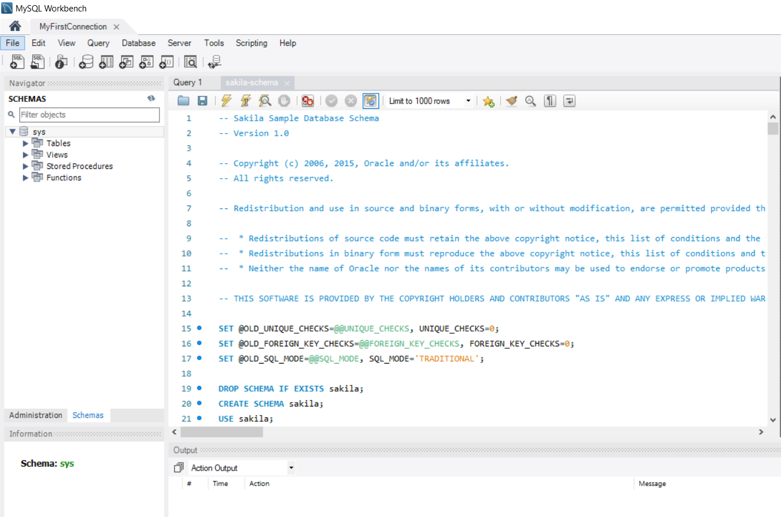

Executing the queries in the file.

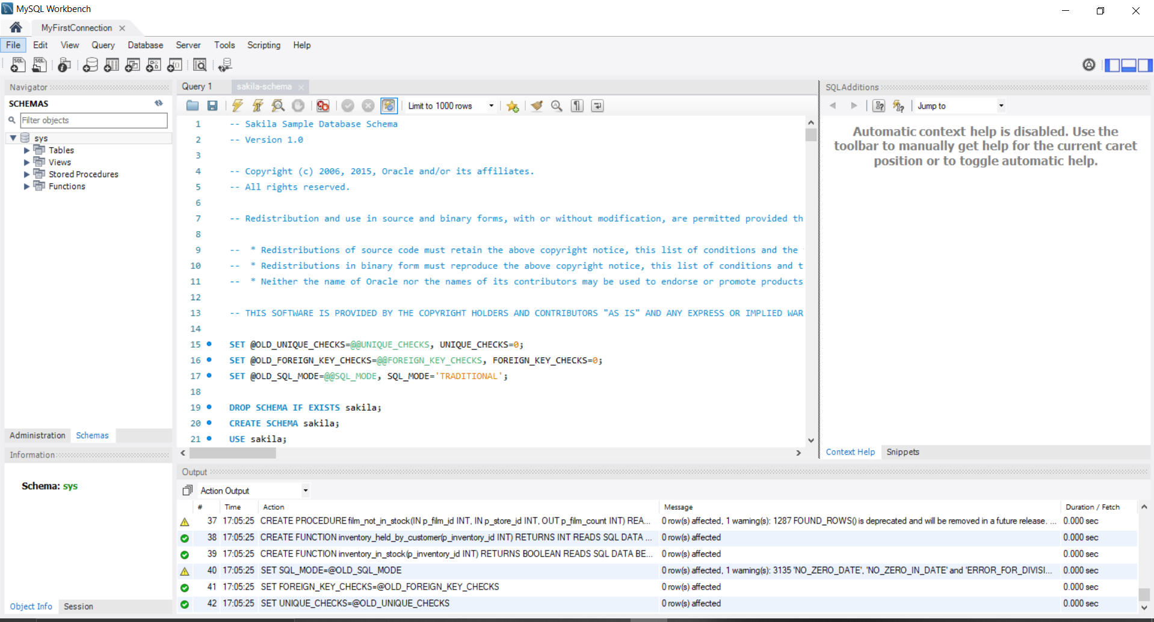

Refreshing the schemes and then the sakila database appears in the schemes pane.

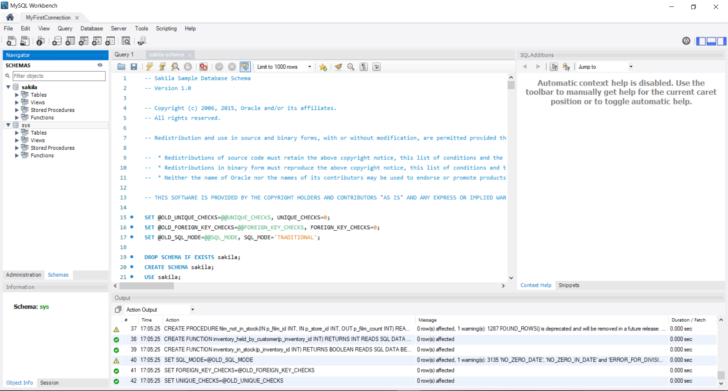

Now opening the sakila-data.sql file.

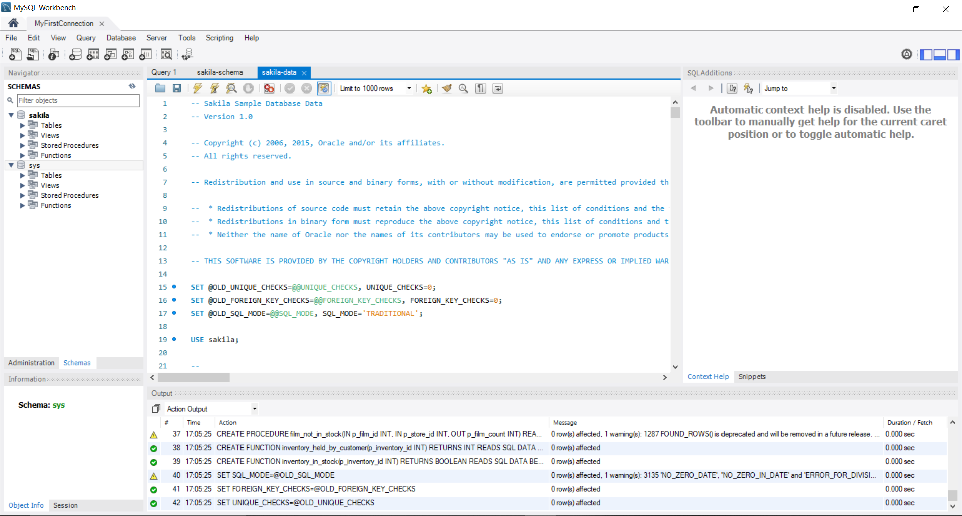

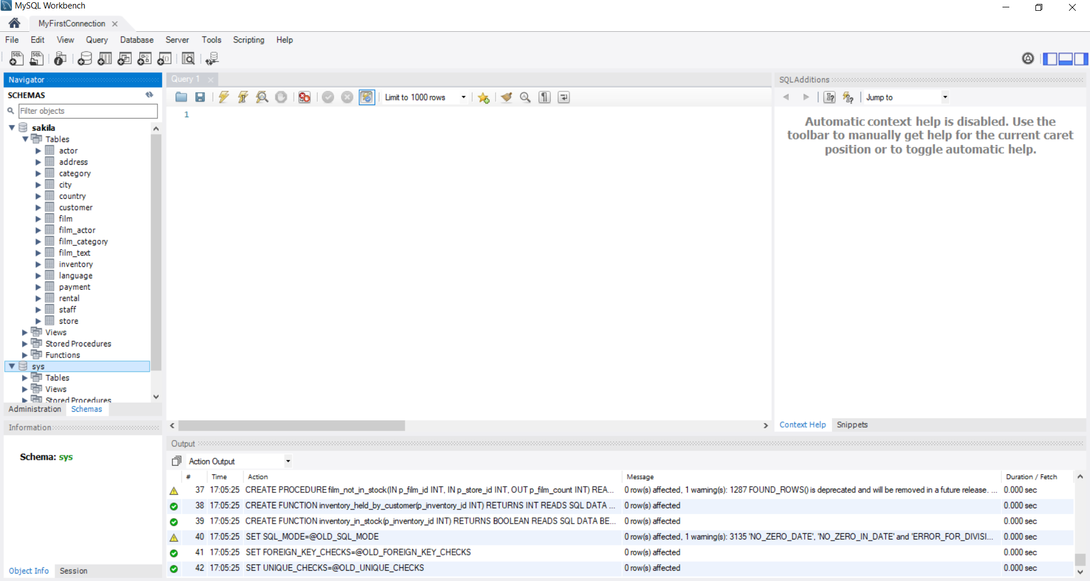

Right clicking on the first table and select the table inspect option.

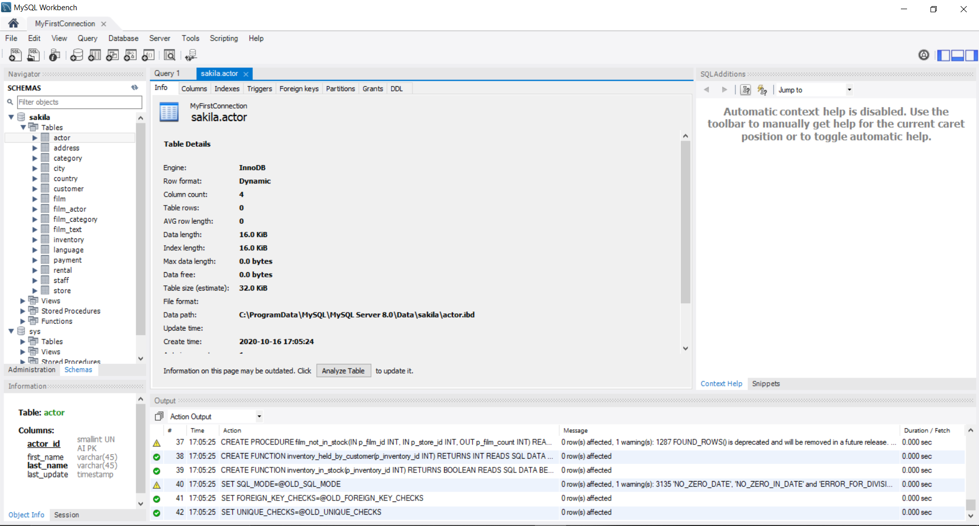

Right clicking the first table and selecting the ‘select rows’ option.

